Brian Engel

Module 3 Assignment

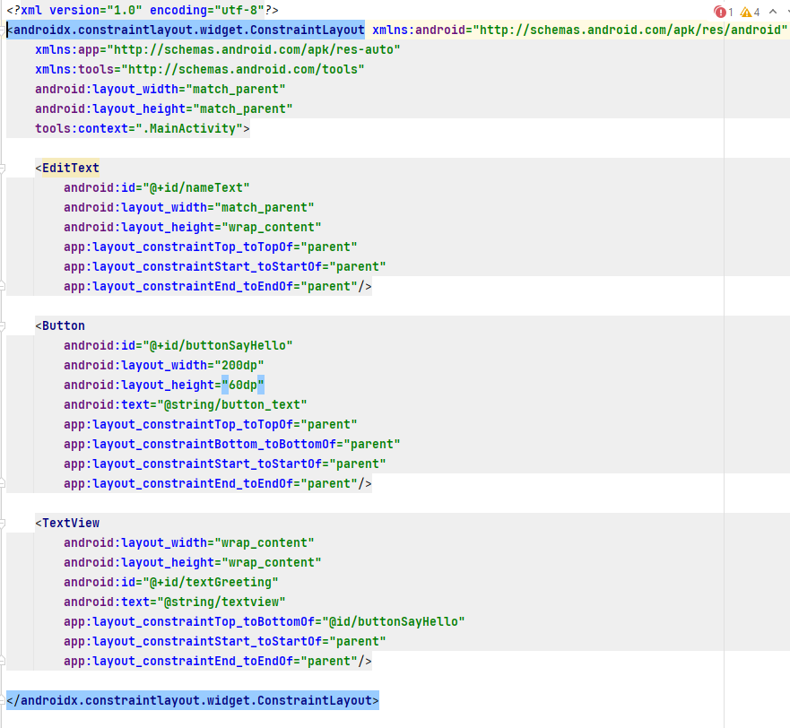

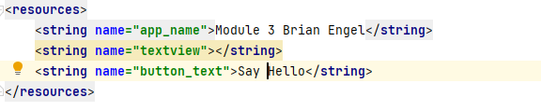

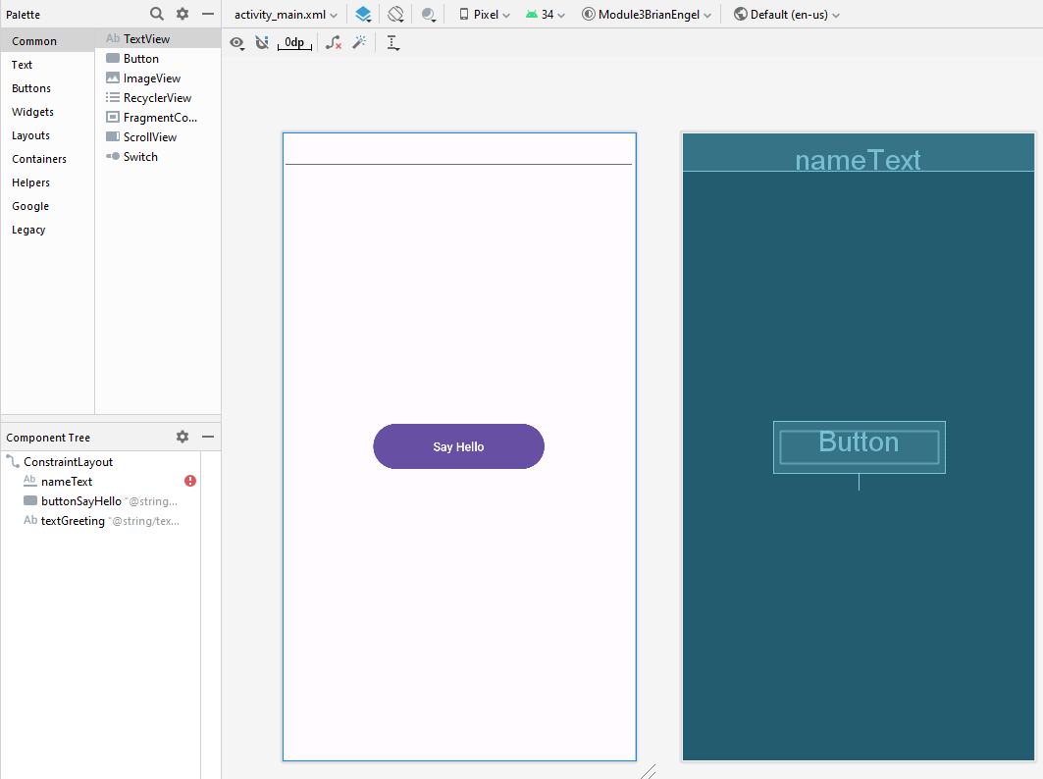

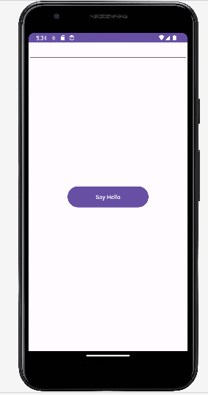

The main challenge that I had in this project was setting up the correct project mode. The empty activity did not give an option to switch to java, so I had to do a little research on Stack Overflow to find the correct template to choose (Empty Views Activity), but that took all of 5 minutes. Everything else was pretty straightforward, and I’ve been doing all the exercises in ZyBooks in Android Studio, so I felt pretty prepared for this. I also tried to use some of what I learned already and kept the strings separate from the activity_main.xml file and put them into the res/values/strings file, and attached a screen shot of that as well. Since we were supposed to remove all of the text from TextView I went ahead and made an empty string for TextView in the strings file and linked that to the activity_main.xml. That way if I need to actually add text to it, I can just add it into the string value already set up for it. I also tried a couple of different things for the positioning of the objects in the application through the use of different constraints. For the EditText I used the constraints of top to top, start to start, and end to end which has the effect of placing it at the top and centered. The Button I did top to top, bottom to bottom, start to start, and end to end which has the effect of centering it vertically and horizontally. The TextView I did top to bottom of the button, and start to start and end to end of the parent, which puts it right below the button and centered with the parent, but of course this has no text in it so nothing actually shows up. (I tested it with text inserted in the string file to make sure it actually works.)